
A
Project Report On
“varsity school”

Towards partial fulfillment of the requirement in
M.Sc. IT & CA
Submitted by

ACADEMIC YEAR: 2025-2026

NAME: VISHAL KUNJERA

M.Sc. ( IT & CA): SEM (1)

Enrollment No: 25CS302PG00487(Vishal)

Project Guide

Prof. Aarti Kubavat



Submitted To:
Shri Matru Mandir College

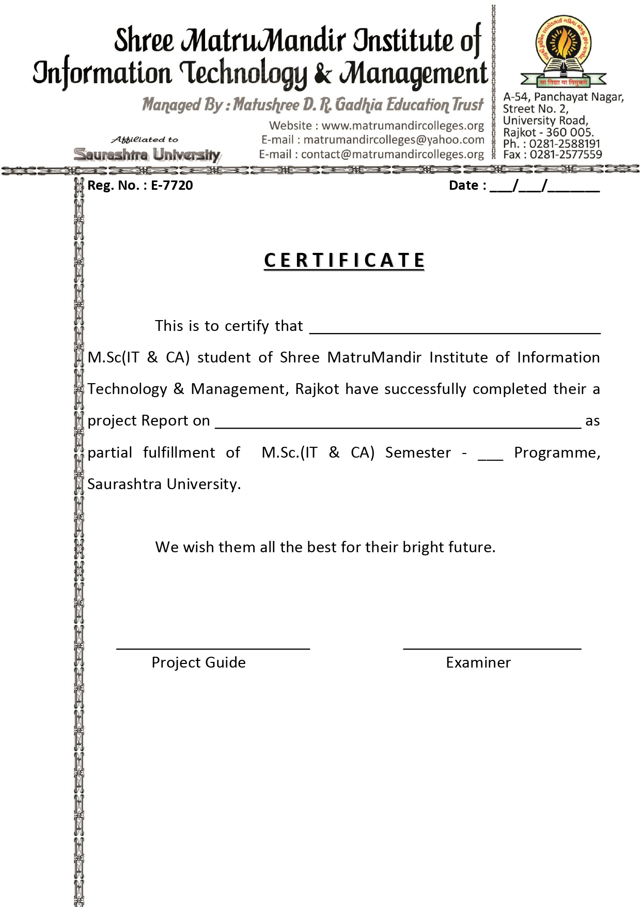

School management
Kunjera Vishal Prakashbhai
1

ACKNOWLEDGEMENT
First and foremost, we would like to express our sincere gratitude to our respected guide, Prof. Aarti Kubavat, for her valuable guidance, continuous support, and motivation throughout the completion of this project. We are truly thankful to her for providing us with this wonderful opportunity to work on the project “SCHOOL MANAGEMENT”.

This project has given us hands-on exposure to various concepts related to school administration modules, web-based system, and database management. Working on this project has enhanced our technical knowledge and improved our practical understanding of how digital systems can simplify day-by-day school operations.

We are also thankful to all our faculty members of Shri Matru Mandir College for their constant encouragement and for sharing their knowledge, which helped us at every stage of this project.

Finally, we would like to thank our classmates, friends, and everyone who directly or indirectly supported us during the development and testing phase of this project.

PREFACE
The project “SCHOOL MANAGEMENT SYSTEM” is designed to provide an efficient and use friendly digital platform for managing various academic and administrative activities within a school. The aim of this system is to simplify day-to-day operations such as student information management, attendance tracking, staff records, timetable scheduling, and overall school administration.
The School Management System focuses on creating a seamless and secure environment where administrators, teachers, students, and parents can access relevant information with ease. The system is developed to be intuitive and easy to navigate, enabling users to perform tasks such as viewing student details, updating records, generating reports, and monitoring academic progress from a single centralized platform.

Every module in this project has been carefully designed and integrated to ensure accuracy, reliability, and smooth workflow management. Our emphasis has been on reducing manual paperwork and promoting a more organized, technology-driven approach to school operations.
We also value user feedback and have aimed to design the system based on practical needs and real-world school requirements. This project reflects our understanding of management systems, database design, and web development concepts, and it serves as a practical implementation of those learnings.

Thank you for taking the time to explore our project. We hope that the School Management System successfully demonstrates a modern, efficient, and fully functional digital approach to school administration.

INDEX

No |  | Description | Page No.
1 |  | Project Summary
 | 1.1 | Project Profile | 7
 | 1.2 | Project Purpose | 8
 | 1.3 | Project Development Model | 9
 | 1.4 | Project Development Scheduling | 10
 | 1.5 | Project scope | 11
 | 1.6 | Technology used | 12
 | 1.7 | Feasibility study | 13
2 |  | System requirement & specification
 | 2.1 | User Characteristics | 14
 | 2.2 | User access flow | 15
 | 2.3 | Proposed system & advantage | 16
 | 2.4 | Hardware & Software requirement | 17
3 |  | Design System
 | 3.1 | Context Diagram | 18
 | 3.2 | Dataflow Diagram | 19
 | 3.3 | ER diagram | 20
 | 3.4 | Use Cases | 21
 | 3.5 | Flow Chart | 22
4 |  | System Design
 | 4.1 | Data dictionary | 24
 | 4.2 | Screenshot of application | 27
 | 4.3 | Conclusion | 33
 | 4.4 | Limitations. | 34
5 |  | Bibliography | 35
1. Project Summary

1.1 Project Profile.
1.2 Project Purpose.
1.3 Project Development Model.
1.4 Project Development Scheduling.
1.5 Project scope.
1.6 Technology Used.
1.7 Feasibility Study.

1.1 Project Profile:

Project Title : School Management
Institution : Rajkot
Front End : HTML, CSS, JavaScript, Bootstrap
Back End : Laravel Framework (PHP), MySQL
Team Size : 1
Project Guide : Prof. AARTI KUBAVAT
Submitted By : Kunjera Vishal Prakasshbhai
Submitted To : Shri Matru Mandir College

1.2 Project definition - purpose

The purpose of the School Management System project is to provide an efficient, user-friendly, and reliable platform to manage all essential school operations. This system enables administrators, teachers, students, and parents to easily access and manage academic information from anywhere.

The main goal of this project is to simplify and automate various tasks such as student registration, attendance tracking, timetable management, fee payment, exam scheduling, and result generation. By digitalizing these processes, the system ensures improved accuracy, faster processing, and smooth communication within the school.

Overall, the purpose of the School Management System is to build a modern, secure, and efficient solution that enhances productivity, reduces paperwork, and supports smooth academic and administrative operations within the school.

1.3 Project Development Model
A software development model provides a structured approach to planning, designing, developing, and delivering a software project. For the School Management System, the Waterfall Model is used because the project requirements are clear, structured, and follow a step-by-step process.

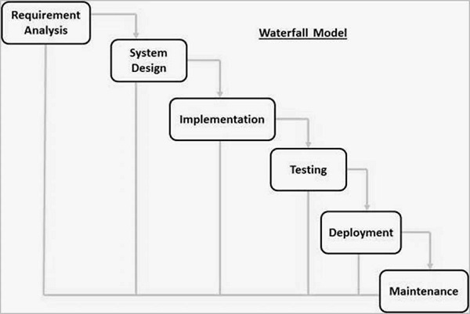

1.4 Project Development Scheduling:

Week  Month | Week 1 | Week 2 | Week3 | Week 4
1st Month | Requirement Gathering | Initial Design | Database Setup | Frontend Development
2nd Month | Backend Development | Integration of Modules | Testing (Phase 1) | Bug Fixes & Improvements
3rd Month | User Testing | Final Debugging | Project Deployment | Post-Deployment Support

1.5 Project scope.
The School Management System (SMS) project focuses on creating a centralized digital platform that streamlines the academic and administrative operations of a school. The system is designed to reduce manual work, minimize errors, and ensure smooth coordination among administrators, teachers, students, and parents.
The scope of the project includes digital management of student admissions, attendance tracking, timetable creation, class scheduling, examination planning, and result generation. Administrators can manage teacher records, assign subjects, monitor activities, and generate detailed reports related to academics, attendance, and overall school performance.
Teachers can use the system to upload study materials, record attendance, create assignments, update marks, and communicate important information to students and parents. Students will have access to class schedules, learning resources, homework updates, exam timetables, results, and announcements. Parents can monitor their child's academic progress, view attendance reports, receive notices, and stay updated on school events.
The system also supports fee management, including fee collection, receipt generation, payment tracking, and automated reminders. Additionally, the project covers the integration of communication tools such as notice boards, alerts, and message notifications to improve interaction within the school community.
Overall, the scope of the School Management System is to provide an organized, efficient, and user-friendly digital environment that enhances school productivity, improves transparency, and supports better academic management.
.

1.6 Technology Used.

What is PHP?
PHP (Hypertext Preprocessor) is a widely used server-side scripting language designed for web development. It allows developers to create dynamic and interactive web pages that can connect with databases, manage sessions, and handle forms. PHP is open-source, easy to learn, and supported by almost all web servers. It works smoothly with HTML, CSS, JavaScript, and MySQL to build complete, data-driven web applications. Laravel — one of the most popular frameworks — is built on PHP, offering faster and more secure development.

What is LARAVEL?
Laravel is a powerful and open-source PHP framework used for building modern web applications quickly and efficiently. It follows the Model–View–Controller (MVC) architecture, which helps developers organize code in a clean and maintainable way. Laravel includes many built-in features like authentication, routing, sessions, and caching that reduce development time. It also provides an expressive syntax and powerful tools for database management, email handling, and API integration. Laravel is beginner-friendly yet strong enough for large-scale enterprise applications, making it one of the most popular frameworks for PHP developers.

What is HTML?
HTML (Hypertext Markup Language) is the basic structure of any website. It defines the layout of content such as text, images, links, and forms on a web page. Web browsers read HTML documents and display them to users as visual web pages. HTML is easy to learn and forms the foundation upon which other technologies like CSS, JavaScript, and Bootstrap work together to make websites dynamic and attractive.

What is CSS?
CSS (Cascading Style Sheets) is used to design and format web pages created with HTML. It defines how the elements should look — including colors, fonts, layout, and spacing. By separating content from design, CSS makes it easier to manage and update website styling. A single CSS file can be used across multiple pages to ensure consistent design and improve website speed. CSS also helps make web pages responsive so they look good on all devices.

What is JAVASCRIPT?
JavaScript is a lightweight programming language that adds interactivity and dynamic features to web pages. It runs directly in the web browser, allowing actions like form validation, animations, and live content updates without reloading the page. JavaScript makes websites more engaging and user-friendly. It is supported by all modern browsers and works closely with HTML and CSS to create powerful front-end experiences.

What is MYSQL?
MySQL is an open-source Relational Database Management System (RDBMS) used to store and manage data efficiently. It organizes data into structured tables that can be easily accessed and updated using Structured Query Language (SQL). MySQL ensures data integrity, supports multiple users, and provides security features for safe access control. It works seamlessly with Laravel to handle backend operations like data storage, user authentication, and reporting in a fast and reliable way.

1.7 Feasibility Study.
A feasibility study is an essential step carried out before starting any project to determine whether it is practical, achievable, and worth pursuing. It helps in understanding if the project can be successfully developed with the available time, budget, and resources. This study involves analyzing several key aspects such as technical feasibility (whether the required technology and tools are available), economic feasibility (if the project is financially beneficial), legal feasibility (whether it complies with laws and regulations), operational feasibility (how effectively it can function within an organization), and schedule feasibility (if it can be completed within the planned timeline).
By carefully evaluating these factors, a feasibility study helps to identify potential challenges early, reduce risks, and ensure better decision-making. It also provides a clear picture of the project’s strengths, weaknesses, and opportunities. Overall, the main objective of conducting a feasibility study is to ensure that the proposed project is both technically sound and economically viable, leading to efficient use of resources and successful implementation.

2. System requirement & specification.

  - User Characteristics.
  - User access flow.
  - Current system.
  - Proposed system & advantage.
    - Proposed system.
    - Advantage of proposed system.
  - Hardware & Software requirement.
2.5.1 Hardware requirement.
2.5.2 Software requirement.

2.1 User characteristics
The School Management System (SMS) project focuses on creating a centralized digital platform that streamlines the academic and administrative operations of a school. The system is designed to reduce manual work, minimize errors, and ensure smooth coordination among administrators, teachers, students, and parents.

The scope of the project includes digital management of student admissions, attendance tracking, timetable creation, class scheduling, examination planning, and result generation. Administrators can manage teacher records, assign subjects, monitor activities, and generate detailed reports related to academics, attendance, and overall school performance.

Teachers can use the system to upload study materials, record attendance, create assignments, update marks, and communicate important information to students and parents. Students will have access to class schedules, learning resources, homework updates, exam timetables, results, and announcements. Parents can monitor their child's academic progress, view attendance reports, receive notices, and stay updated on school events.

2.2 User access Flow
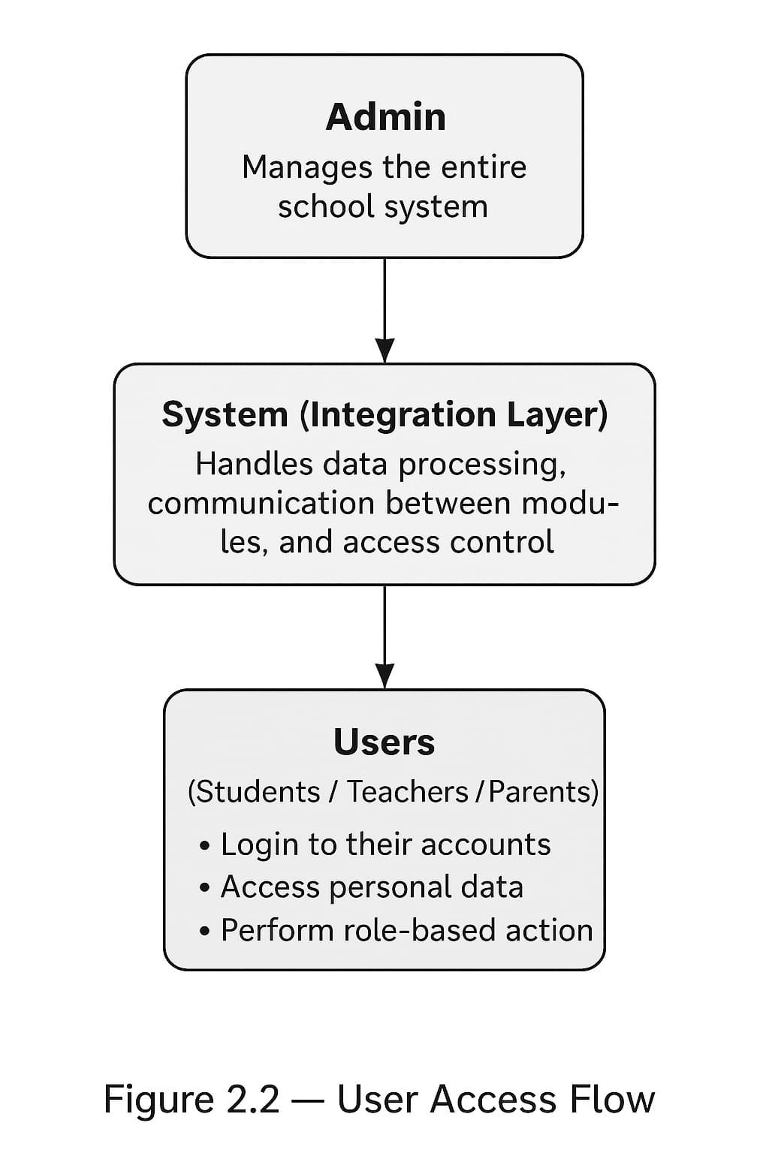

2.3 Proposed system & advantages

Proposed System
The proposed system is a role-based School Management System designed to simplify and automate school operations. It provides a centralized admin panel, a teacher dashboard, and student/parent portals for smooth management of academic and administrative tasks.
Admins can manage students, classes, attendance, exams, staff, and fees. Teachers can take attendance, upload materials, and track student performance. Students and parents can view timetables, marks, notifications, and academic updates.

Advantages of the Proposed System
- Improved Efficiency
Automation of attendance, results, fees, and timetables reduces manual work and errors, speeding up school operations.
- Secure & Centralized Data
All data is stored safely in one system with role-based access, ensuring privacy and preventing unauthorized changes.
- Better Communication
Notifications, announcements, and performance updates keep teachers, students, and parents connected and informed.
- User-Friendly Interface
Clean dashboards and simple navigation make the system easy to use for all users, improving overall experience.

2.4 Software& hardware requirement

2.4.1 Hardware requirement:
To run and test the project smoothly, the following minimum hardware configuration is required:
- Processor: Intel Core 2 Duo or higher
- RAM: Minimum 4 GB (8 GB recommended)
- Hard Disk: 500 GB or more
- Monitor: Standard Display (15” or higher)
- Keyboard & Mouse: Standard Input Devices

    - Software requirement:
The project is developed using modern web technologies along with the Laravel framework.
Below are the required software tools and versions for proper setup and execution:
- Operating System: Windows 10 / 11 or Ubuntu Linux
- Front-End Technologies: HTML, CSS, JavaScript, Bootstrap
- Back-End Technologies: PHP (Version 8.1 or higher), Laravel (Version 10.x)
- Database: MySQL (Version 8.0 or higher)
- Web Server: Apache or Nginx (via XAMPP / Laragon / WAMP)
- Composer: Dependency Manager for PHP (latest stable version)
- Code Editor: Visual Studio Code / Sublime Text / PHPStorm
- Browser: Google Chrome / Mozilla Firefox (latest version)

3. Design System
3.1 Context Diagram.
3.2 Dataflow Diagram.
3.3 ER diagram.
3.4 Use Cases
3.5 Flow Chart
3.1 Context Diagram:
Data flow diagrams can be used to provide a clear representation of any business function. The technique starts with an overall picture of the business and continues by analyzing each of the functional areas of interest. This analysis can be carried out to precisely the level of detail required. The technique exploits a method called top-down expansion to conduct the analysis in a targeted way.
- Admin (manage students, manage students, manage classes, manage exams)
- Teacher (attedance, marks, materials)
- Student(login request, assignment submission, results, timetable)
- parent (fee payment info, feedback)

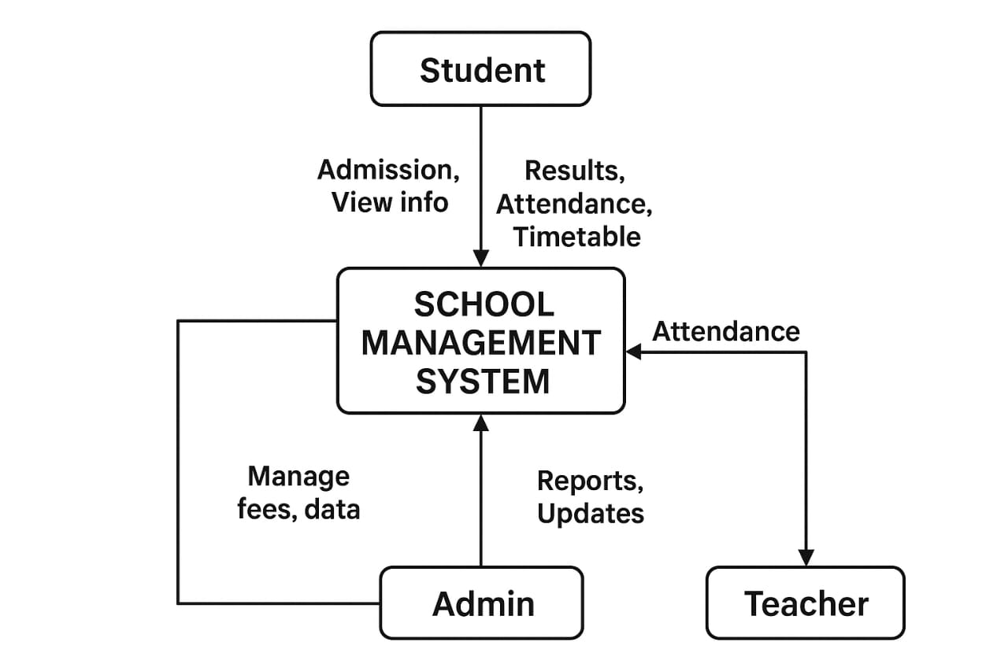
1ST LEVEL DFD

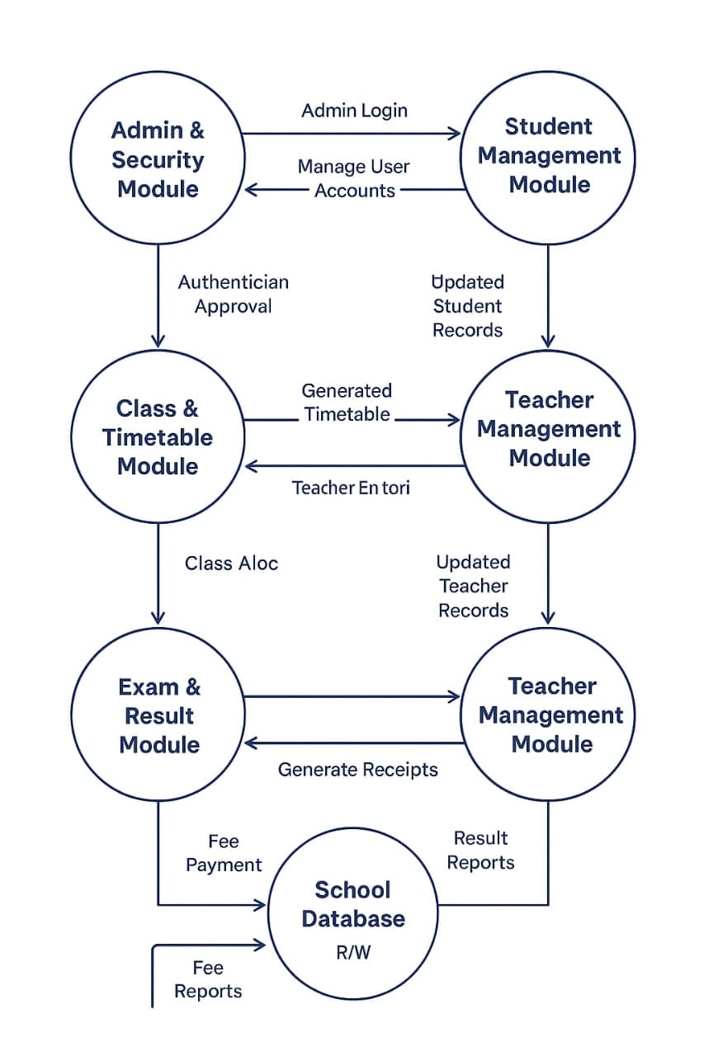

2ND LEVEL DFD

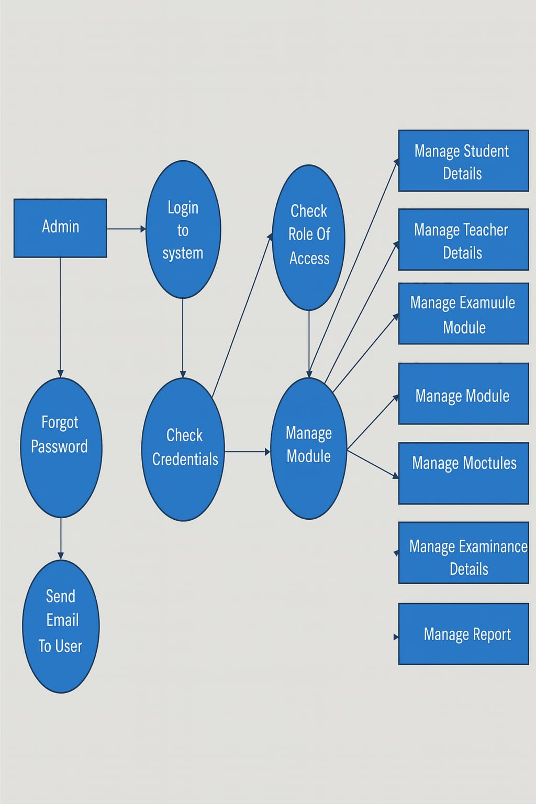

ER-Diagram:

The ER diagram model also called “An Entity Relationship Diagram” is a graphical representation of entities and their relationship to each other, typically used in computing in regard to organization of data within databases or information system.

An entity relationship diagram is a data modeling technique that can help define business process and can be used as foundation for relational database. The shapes we have used in E-R Diagrams are as follows.
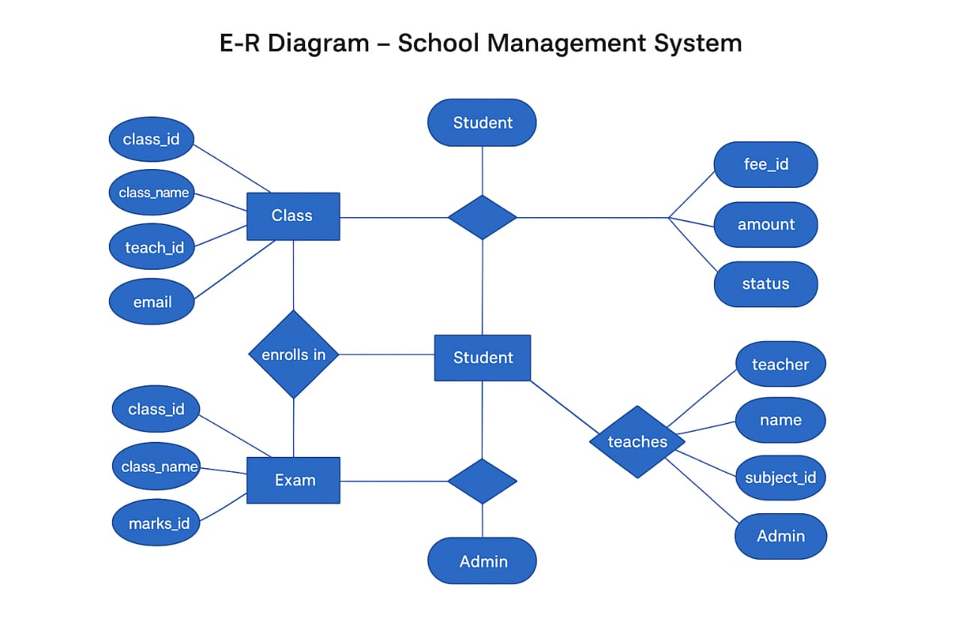

3.4 Use-Cases:

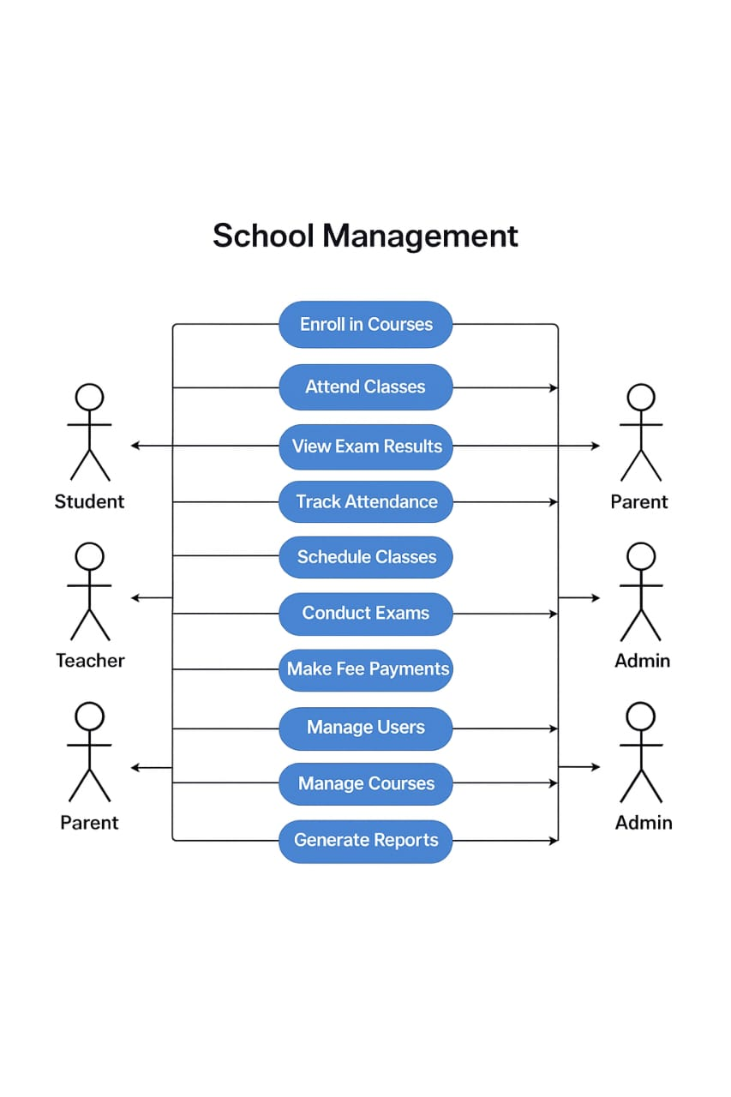

Flow chart

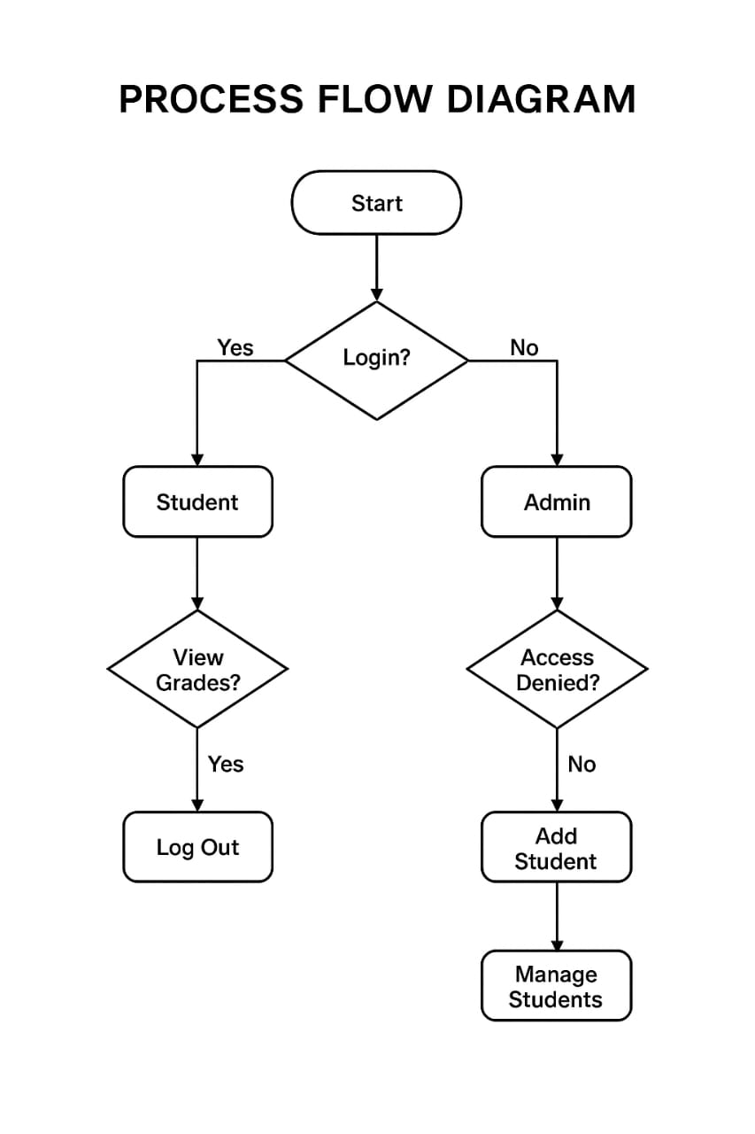

4. System Design
4.1 Data dictionary
User:

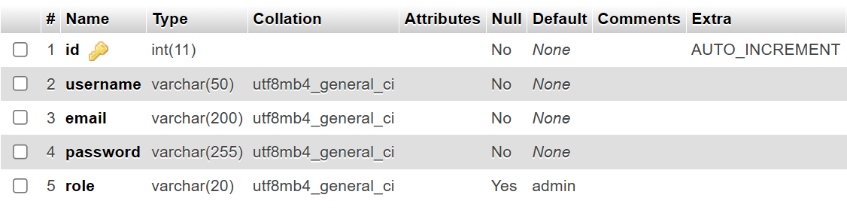
Student:

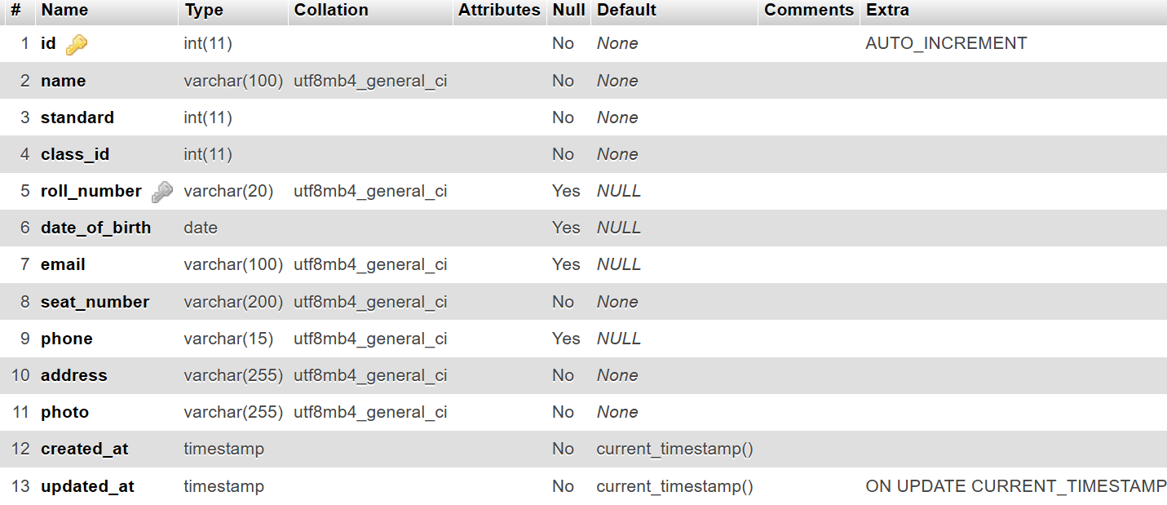
Exam:

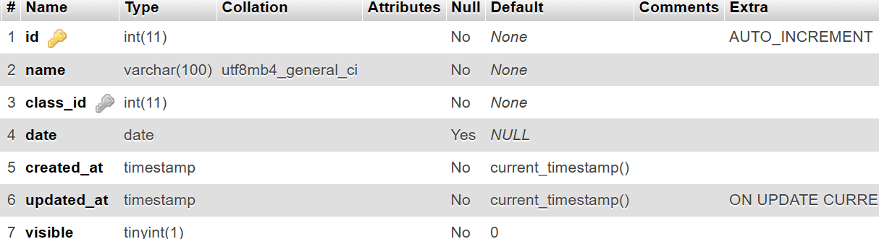
Teacher:

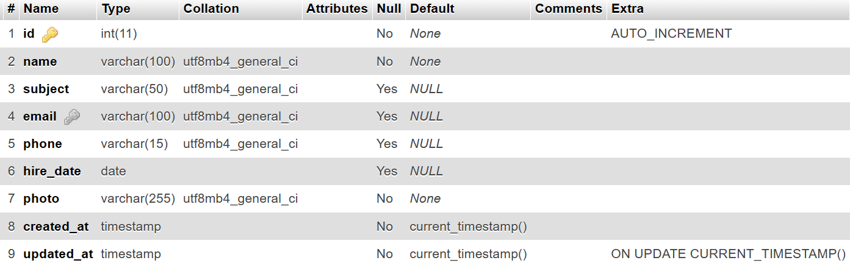

Settings:

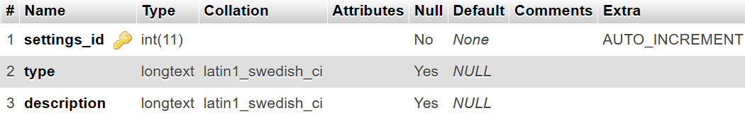
Classes:

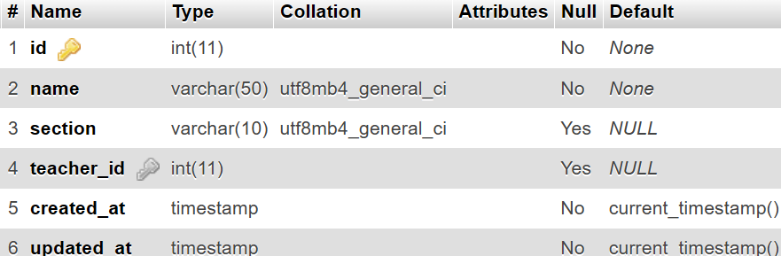

Photos:

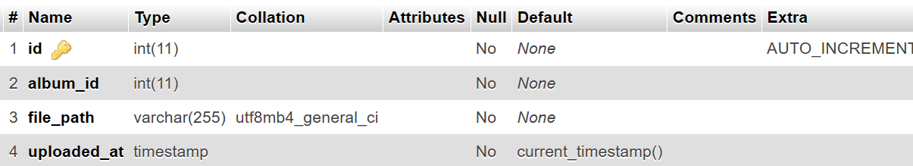

4.2 Screen shot of application:

- At admins Login/
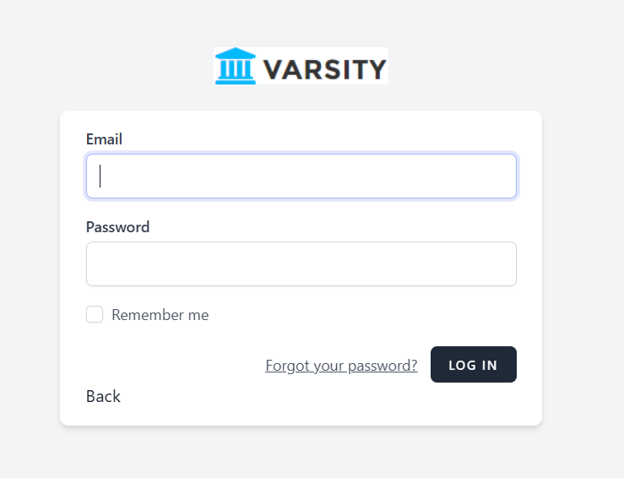
- Dashboard

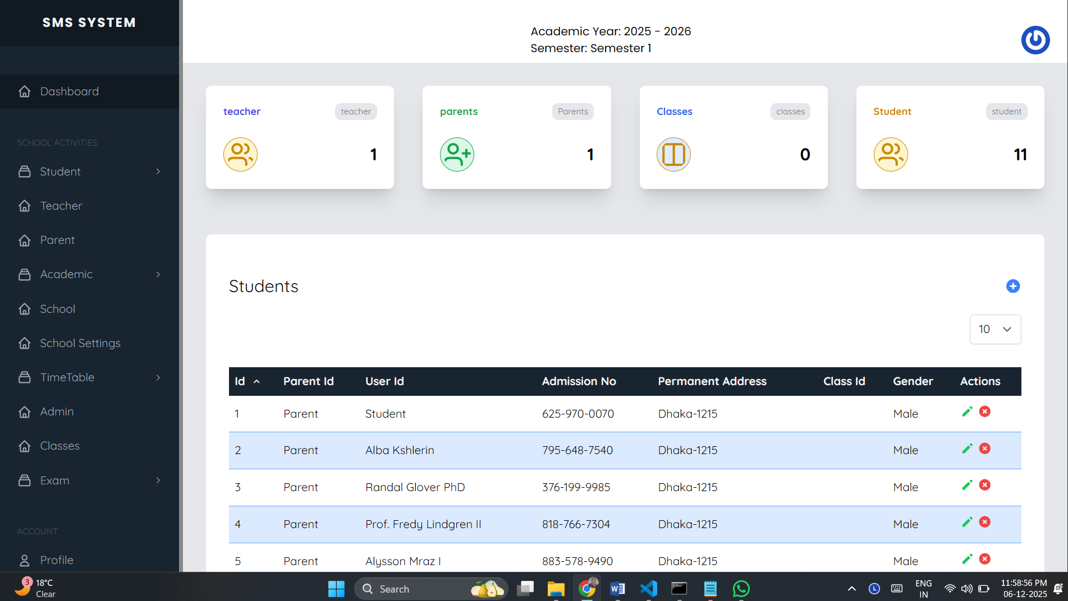

- Academic year setting
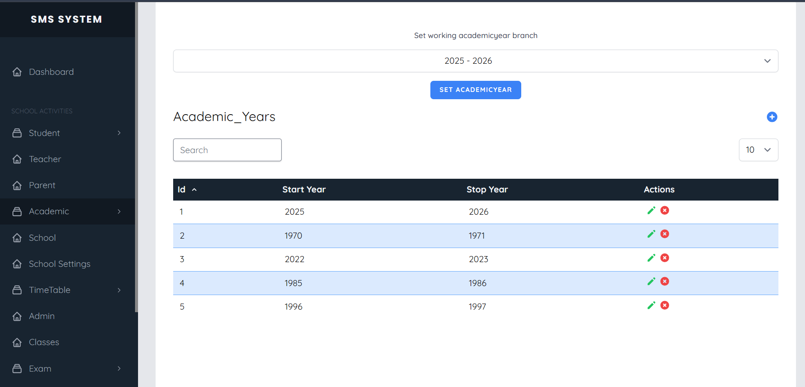

- School setting

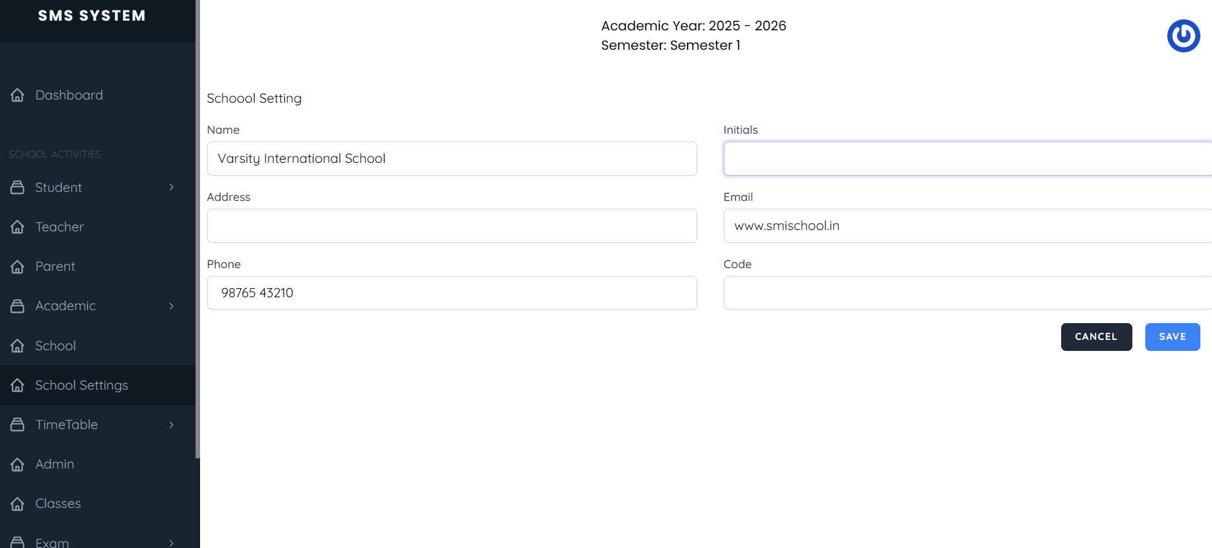

- Subjects
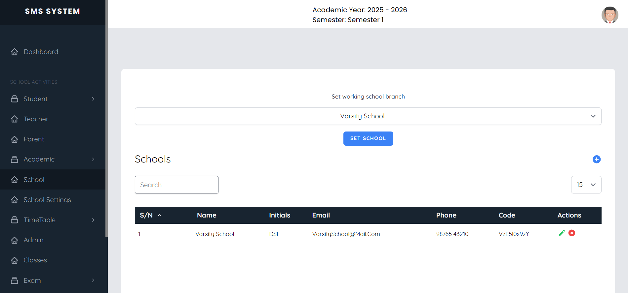

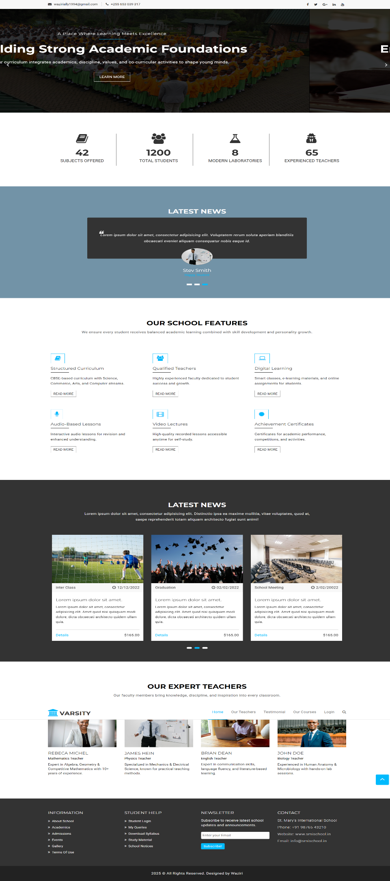
Client
- Home page
Conclusion

In conclusion, the School Management System project successfully provides an efficient and streamlined solution for managing academic and administrative activities within an educational institution. The system is designed to simplify complex processes such as student admissions, attendance monitoring, timetable management, teacher coordination, fee processing, and exam/result management.
Developed using modern web technologies, the platform ensures reliability, accuracy, and ease of use. Administrators can efficiently oversee daily operations, teachers can manage class-related activities, and students can conveniently access academic information — all through a clean and user-friendly interface.
Overall, this project demonstrates the practical application of full-stack development principles in creating a robust, scalable, and secure system. It highlights how technology can enhance institutional productivity, improve communication, and provide better accessibility for all users. The School Management System stands as a strong example of how digital solutions can transform traditional school operations into a more efficient and organized environment.

Limitations
1. Limited Integration

The system currently integrates only with basic academic features and lacks advanced integrations such as SMS gateways, biometric attendance, or cloud-based backup services.

2. Scalability Constraints

Although functional for small to medium-sized institutions, the system may experience reduced performance when handling a very large number of users, records, or concurrent operations.

3. Limited Customization

Users have restricted customization options for themes, dashboard layouts, and automated workflows. Additional personalization features could improve user experience.

4. Security Enhancements Needed

While basic security protocols are implemented, the system may require enhanced encryption, role-based access improvements, and advanced data protection methods for sensitive student and staff information.

5. Mobile Optimization

The platform is responsive, but certain modules may require further UI adjustments and optimization for smooth usage on mobile devices.

6. Offline Accessibility

The system operates only with an active internet connection. Offline functionality for attendance or data entry is not supported.
5. Bibliography

    - Book Reference:
https://laravel.com/docs/9.x

    - WEB Reference:
https://laravel.com/docs/9.x

